VISVESVARAYA TECHNOLOGICAL UNIVERSITY

Jnana Sangama, Belagavi - 590018



Mini Project Report

on

“BE HEALTHY”

Submitted in partial fulfillment of the requirements for the award of the degree of

BACHELOR OF ENGINEERING

in

COMPUTER SCIENCE & ENGINEERING

by

THANMAYEE N SHETTY 4MT20CS171

TEJASWINI PEERU GOUDA 4MT20CS170

Under the Guidance of

MR. SHIVAPRASAD T K

(Senior Assistant Professor)



DEPARTMENT OF COMPUTER SCIENCE & ENGINEERING

*(Accredited by NBA)*

MANGALORE INSTITUTE OF TECHNOLOGY & ENGINEERING

*Accredited by NAAC with A+ Grade, An ISO 9001: 2015 Certified Institution*

(*A Unit of Rajalaxmi Education Trust®, Mangalore - 575001*)

Affiliated to VTU, Belagavi, Approved by AICTE, New Delhi

Badaga Mijar, Moodabidri-574225, Karnataka

2022-23

**MANGALORE INSTITUTE OF TECHNOLOGY & ENGINEERING**

*Accredited by NAAC with A+ Grade, An ISO 9001: 2015 Certified Institution*

*(A Unit of Rajalaxmi Education Trust®, Mangalore - 575001)*

Affiliated to V.T.U., Belagavi, Approved by AICTE, New Delhi.

**Department of Computer Science & Engineering**

*(Accredited by NBA)*

**CERTIFICATE**

This is to certify that the mini project entitled **BE HEALTHY** is carried out by **THANMAYEE N SHETTY (4MT20CS171) AND TEJASWINI PEERU GOUDA(4MT20CS170)** in partial fulfilment for the requirement of 6th semester Mobile Application Development (18CSMP68). It is certified that all the corrections / suggestions indicated for the Internal Assessment have been incorporated in the report. The mini project has been approved as it satisfies the academic requirement in respect of the 18CSMP68 prescribed for the 6th Semester B.E in Computer Science & Engineering Program by the **Visvesvaraya Technological University, Belagavi**, for the academic year 2022 – 2023.

**………………………… …………………………**

**Mr. Shivaprasad T K Dr. Ravinarayana B**

Senior Assistant Professor, Associate Professor & HOD

MITE, Moodabidri MITE, Moodabidri

**Name of the Examiners Signature with Date**

**1. ………………………. 1. …………………………**

**2. ………………………. 2. …………………………**

**ACKNOWLEDGEMENT**

The successful completion of any significant task is the outcome of invaluable aggregate combination of different people in radial direction explicitly and implicitly. We would therefore take opportunity to thank and express our gratitude to all those without whom the completion of project would not be possible.

We express our thanks to **Mr. Shivaprasad T K, Senior Assistant Professor ,** **Department of Computer Science and Engineering** for having provided all the facilities that helped us in timely completion of this project.

We express our sincere gratitude to **Dr. Ravinarayana B, Associate Professor, Head of the Department, Computer Science and Engineering** for his support and guidance.

We would like to thank **Prof. Prashanth C M, Principal, Mangalore Institute of Technology and Engineering, Moodabidri** for his support and encouragement.

We express our sincere gratitude to our institution and management for providing us with good infrastructure, laboratory facilities, qualified and inspiring staffs, and whose guidance was of immense help in completion of this seminar successfully.

**THANMAYEE N SHETTY (4MT20CS171)**

**TEJASWINI PEERU GOUDA (4MT20CS170)**

**ABSTRACT**

Be Healthy is a healthcare platform aimed at revolutionizing the way patients access and manage their healthcare services. By integrating various features into a single platform, Be Healthy offers a seamless and convenient experience for users. It includes an online pharmacy where prescribed medicines can be purchased, eliminating the need for physical visits to a pharmacy. The platform also incorporates a robust search functionality, enabling users to find and select doctors and healthcare professionals based on their qualifications and experience. This empowers patients to make informed decisions about their healthcare providers. Additionally, Be Healthy provides users with health tips and information to promote a healthy lifestyle. By streamlining the healthcare experience, Be Healthy aims to make healthcare more accessible, user-friendly, and efficient for individuals, empowering them to take control of their health and well-being.

**TABLE OF CONTENTS**

|  |  |  |
| --- | --- | --- |
| **Sl. No** | **CONTENT** | **PAGE NO** |
|  |  |  |
| **1.** | **INTRODUCTION** 1.1 : Mobile Application Development | **1** |
| **2.** | **LITERATURE WORK**  **2.1 : Android Studio**  **2.2 : Java**  **2.3 : XML** | **2**  **2**  **3** |
| **3.** | **SYSTEM DESIGN** | **4** |
| **4.** | **IMPLEMENTATION**  **4.1 : XML Code**  **4.2 : Java Code** | **5**  **11** |
| **5.** | **RESULTS AND DISCUSSIONS** | **16** |
| **6.** | **CONCLUSION**  **6.1 : Conclusion**  **6.2 : Future enhancements** | **20** |
|  | **REFERENCES** | **21** |

**LIST OF FIGURES**

|  |  |  |
| --- | --- | --- |
| **Sl. No.** | **TITLE** | **PAGE NO.** |
|  |  |  |
| **Figure 4.1.1** | **XML code for Home page** | **5** |
| **Figure 4.1.2**  **Figure 4.2.1** | **XML code for Order details page**  **JAVA code for Home page** | **9**  **11** |
| **Figure 4.2.2** | **JAVA code for Order details page** | **13** |
| **Figure 5.1** | **Home Page** | **16** |
| **Figure 5.2** | **Login page** | **16** |
| **Figure 5.3** | **Find doctor page** | **17** |
| **Figure 5.4** | **Book doctor page** | **17** |
| **Figure 5.5** | **Order details page** | **18** |
| **Figure 5.6** | **Booking page** | **18** |
| **Figure 5.7**  **Figure 5.8** | **Articles page**  **Buy medicine page** | **19**  **19** |
|  |  |  |

**Chapter 1**

**INTRODUCTION**

## Mobile Application Development

Mobile application development is a dynamic and ever-evolving process focused on designing software applications specifically tailored to operate on mobile devices. These applications leverage network connections to access remote computing resources, enabling a wide range of functionalities for users. One of the dominant platforms for mobile app development is Android, which utilizes programming languages like Java or Kotlin. The widespread adoption of smartphones and tablets across various industries has created a high demand for mobile applications.

In conclusion, mobile application development is a dynamic and evolving field that empowers developers to create software applications for mobile devices. The constant advancements in mobile technologies and the emergence of new programming languages and tools ensure that the field remains vibrant and full of potential for developers to explore and innovate.

**Chapter 2**

**LITERATURE WORK**

## 2.1 ANDROID STUDIO

Android Studio is Google's official integrated development environment (IDE), built on JetBrains' IntelliJ IDEA software and developed exclusively for Android programming. From 2020, it was available for download on Windows, macOS, and Linux-based operating systems, as well as a subscription-based service. It is the major IDE for native Android application development, replacing the Eclipse Android Development Tools (E-ADT). Android Studio was announced during the Google I/O conference on May 16, 2013. It was in the early access preview stage beginning with version 0.1 in May 2013, then entered the beta stage beginning with version0.8 in June 2014. Starting with version 1.0, the first stable build was released in December 2014.

## 2.2 JAVA

Java is a high-level, class-based, object-oriented programming language with a low number of implementation dependencies. It is a general-purpose programming language designed to allow application developers to write once and run anywhere (WORA), which means that compiled Java code can operate on all platforms that support Java without requiring recompilation. Java program are often compiled to byte code that can run on any Java virtual machine (JVM), regardless of computer architecture. Java's syntax is comparable to those of C and C++, but it has fewer low-level features than any of them, the Java runtime provides dynamic capabilities (such as reflection and runtime code modification) that traditional compiled languages do not. As of 2019, Java was one of the most popular programming languages in use according to GitHub, particularly for client-server web applications, with a reported 9 million developers.

## 2.3 XML

XML (Extensible Markup Language) is a markup language that defines a set of rules for encoding documents in a format that is both human-readable and machine-readable. The World Wide Web Consortium's XML 1.0 Specification of 1998 and several other related specifications. This is a powerful way to store data in a format that can be stored, searched and shared. Most importantly, since the fundamental of XML is standardized, if you share or transmit XML across systems or platforms, either locally or over the internet, the recipient can still parse the data due to standardized XML syntax.

**Chapter 3**

**SYSTEM DESIGN**

We use XML for the layout of the app in the project's design. The logical component of the elements is written in Java. There are various uses for XML on Android, each of which requires a different sort of xml file. For the many reasons described earlier, XML is well used in defining the UI of the program. XML standard is a versatile method for creating information formats and electronically sharing structured data via the public Internet and business networks. In order to develop a unique user interface, XML also aids in delivering various graphics to the elements or views. We have also included Drawable XML files.

The register module in the Be Healthy platform enables users to create an account by providing their name, email, and password. Both modules work together to provide a secure and convenient user experience, allowing individuals to efficiently manage their healthcare needs within the Be Healthy platform.

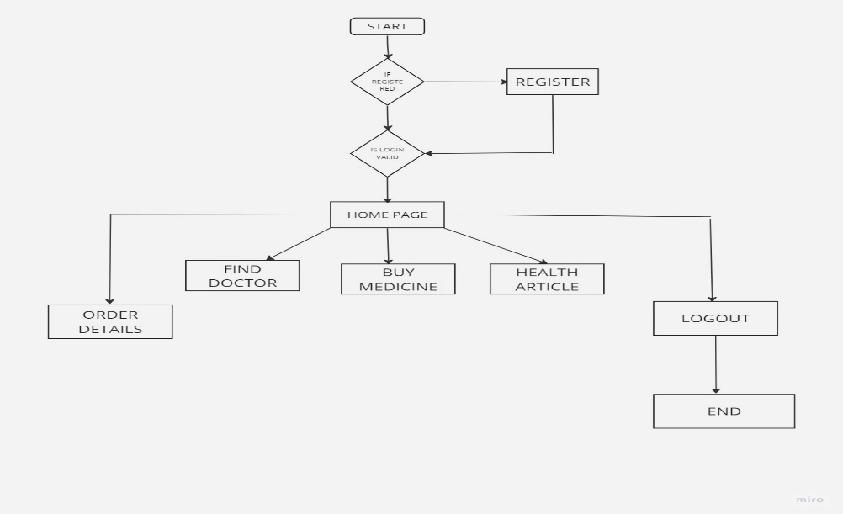

**Figure 3.1 : Flow chart**

**Chapter 4**

**IMPLEMENTATION**

**4.1 XML CODEs**

<?xml version="1.0" encoding="utf-8"?>

<androidx.constraintlayout.widget.ConstraintLayout xmlns:android="http://schemas.android.com/apk/res/android"

xmlns:app="http://schemas.android.com/apk/res-auto"

xmlns:tools="http://schemas.android.com/tools"

android:layout_width="match_parent"

android:layout_height="match_parent"

android:background="@drawable/frontpage4"

android:descendantFocusability="beforeDescendants"

android:drawingCacheQuality="high"

tools:context=".LoginActivity">

<EditText

android:id="@+id/editTextLoginPassword"

android:layout_width="353dp"

android:layout_height="54dp"

android:background="@drawable/input_bg"

android:drawableLeft="@drawable/ic_baseline_security_24"

android:drawablePadding="10dp"

android:ems="10"

android:hint="Password"

android:inputType="textPassword"

android:paddingLeft="20dp"

android:paddingTop="10dp"

android:paddingRight="10dp"

android:paddingBottom="10dp"

android:textColor="@color/colorBlack"

android:textStyle="bold"

app:layout_constraintBottom_toBottomOf="parent"

app:layout_constraintEnd_toEndOf="parent"

app:layout_constraintStart_toStartOf="parent"

app:layout_constraintTop_toTopOf="parent"

app:layout_constraintVertical_bias="0.586" />

<TextView

android:id="@+id/textViewBMTitle"

android:layout_width="239dp"

android:layout_height="53dp"

android:text="BE HEALTHY"

android:textAlignment="center"

android:textColor="@color/white"

android:textSize="34sp"

android:textStyle="bold"

app:layout_constraintBottom_toBottomOf="parent"

app:layout_constraintEnd_toEndOf="parent"

app:layout_constraintStart_toStartOf="parent"

app:layout_constraintTop_toTopOf="parent"

app:layout_constraintVertical_bias="0.084" />

<TextView

android:id="@+id/textViewAppTitle"

android:layout_width="142dp"

android:layout_height="61dp"

android:text="Login"

android:textAlignment="center"

android:textColor="#9C27B0"

android:textSize="34sp"

android:textStyle="bold"

app:layout_constraintBottom_toBottomOf="parent"

app:layout_constraintEnd_toEndOf="parent"

app:layout_constraintHorizontal_bias="0.498"

app:layout_constraintTop_toTopOf="parent"

app:layout_constraintVertical_bias="0.3" />

<EditText

android:id="@+id/editTextLoginUsername"

android:layout_width="353dp"

android:layout_height="54dp"

android:background="@drawable/input_bg"

android:drawableLeft="@drawable/ic_baseline_person_24"

android:hint="Username"

android:inputType="text"

android:paddingLeft="20dp"

android:paddingBottom="10dp"

android:textColor="@color/colorBlack"

android:textStyle="bold"

android:text="Login”

app:layout_constraintBottom_toBottomOf="parent"

app:layout_constraintTop_toTopOf="parent"

app:layout_constraintVertical_bias="0.831" />

app:layout_constraintEnd_toEndOf="parent"

app:layout_constraintStart_toStartOf="parent"

app:layout_constraintTop_toTopOf="parent”

app:layout_constraintVertical_bias="0.459" />

**Figure 4.1.1 : XML Code snippet of Home page**

<Button

android:id="@+id/buttonLogin"

android:layout_width="322dp"

android:layout_height="51dp"

android:text="Login"

app:layout_constraintBottom_toBottomOf="parent"

app:layout_constraintEnd_toEndOf="parent"

app:layout_constraintStart_toStartOf="parent"

app:layout_constraintTop_toTopOf="parent"

app:layout_constraintVertical_bias="0.71" />

<TextView

android:id="@+id/textViewNewUser"

android:layout_width="188dp"

android:layout_height="23dp"

android:text="Register for new user"

android:textAlignment="center"

android:textColor="@color/colorWhite"

android:textStyle="bold"

app:layout_constraintBottom_toBottomOf="parent"

app:layout_constraintEnd_toEndOf="parent"

app:layout_constraintHorizontal_bias="0.497"

app:layout_constraintStart_toStartOf="parent"

app:layout_constraintTop_toTopOf="parent"

app:layout_constraintVertical_bias="0.831" />

</androidx.constraintlayout.widget.ConstraintLayout>

</androidx.constraintlayout.widget.ConstraintLayout>

<?xml version="1.0" encoding="utf-8"?>

<androidx.constraintlayout.widget.ConstraintLayout xmlns:android="http://schemas.android.com/apk/res/android"

xmlns:app="http://schemas.android.com/apk/res-auto"

xmlns:tools="http://schemas.android.com/tools"

android:layout_width="match_parent"

android:layout_height="match_parent"

android:background="@drawable/newback1"

tools:context=".OrderDetailsActivity">

<TextView

android:id="@+id/textView_logo3"

android:layout_width="wrap_content"

android:layout_height="wrap_content"

android:text="BE HEALTHY"

android:textColor="@color/purple_200"

android:textSize="34sp"

android:textStyle="bold"

app:layout_constraintBottom_toBottomOf="parent"

app:layout_constraintEnd_toEndOf="parent"

app:layout_constraintStart_toStartOf="parent"

app:layout_constraintTop_toTopOf="parent"

app:layout_constraintVertical_bias="0.045" />

<TextView

android:id="@+id/textViewODTitle"

android:layout_width="wrap_content"

android:layout_height="wrap_content"

android:text="ORDER DETAILS"

android:textColor="@color/colorWhite"

android:textSize="20sp"

android:textStyle="bold"

app:layout_constraintBottom_toBottomOf="parent"

app:layout_constraintEnd_toEndOf="parent"

app:layout_constraintStart_toStartOf="parent"

app:layout_constraintTop_toBottomOf="@+id/textView_logo3"

app:layout_constraintVertical_bias="0.01999998" />

<ListView

android:id="@+id/listViewOD"

android:layout_width="344dp"

android:layout_height="523dp"

android:layout_marginStart="-40dp"

android:layout_marginTop="12dp"

android:layout_marginEnd="-40dp"

app:layout_constraintHorizontal_bias="0.51"

app:layout_constraintEnd_toEndOf="@+id/textViewODTitle"

app:layout_constraintStart_toStartOf="@+id/textViewODTitle"

app:layout_constraintTop_toBottomOf="@+id/textViewODTitle” />

<Button

android:id="@+id/buttonODBack"

android:layout_width="wrap_content"

android:layout_height="wrap_content"

android:text="BACK"

app:layout_constraintBottom_toBottomOf="parent"

app:layout_constraintEnd_toEndOf="parent"

app:layout_constraintStart_toStartOf="parent"

app:layout_constraintVertical_bias="0.69” />

</androidx.constraintlayout.widget.ConstraintLayout>

**Figure 4.1.2 : XML Code snippet of Order Details page**

**4.2 JAVA CODE**

package com.example.myapplication;

import androidx.appcompat.app.AppCompatActivity;

import androidx.cardview.widget.CardView;

import android.content.Context;

import android.content.Intent;

import android.content.SharedPreferences;

import android.os.Bundle;

import android.view.View;

import android.widget.Toast;

public class HomeActivity extends AppCompatActivity {

@Override

protected void onCreate(Bundle savedInstanceState) {

super.onCreate(savedInstanceState);

setContentView(R.layout.activity_home);

SharedPreferences sharedpreferences = getSharedPreferences("shared_prefs", Context.MODE_PRIVATE);

String username =sharedpreferences.getString("username","").toString();

Toast.makeText(getApplicationContext()," Welcome" +username, Toast.LENGTH_SHORT).show();

CardView exit =findViewById(R.id.cardExit); startActivity(new Intent(HomeActivity.this, LoginActivity.class));

exit.setOnClickListener(new View.OnClickListener() {

@Override

public void onClick(View view)

SharedPreferences.Editor editor= sharedpreferences.edit();

editor.clear(); editor.apply();

SharedPreferences.Editor editor= sharedpreferences.edit();

editor.clear(); editor.apply();

startActivity(new Intent(HomeActivity.this, LoginActivity.class)); } });

CardView findDoctor =findViewById(R.id.cardFindDoctor);

findDoctor.setOnClickListener(new View.OnClickListener() {

@Override

public void onClick(View view) {

startActivity(new Intent(HomeActivity.this,FindDoctorActivity.class)); } });

CardView orderDetails =findViewById(R.id.cardOrderDetails);

orderDetails.setOnClickListener(new View.OnClickListener() {

@Override

public void onClick(View view) {

startActivity(new Intent(HomeActivity.this,OrderDetailsActivity.class)); } });

CardView buyMedicine =findViewById(R.id.cardBuyMedicine);

buyMedicine.setOnClickListener(new View.OnClickListener() {

@Override

public void onClick(View view) {

startActivity(new Intent(HomeActivity.this,BuyMedicineActivity.class)); } });

CardView health =findViewById(R.id.cardHealthDoctor);

health.setOnClickListener(new View.OnClickListener() {

@Override

public void onClick(View view) {

startActivity(new Intent(HomeActivity.this,HealthArticleActivity.class));

}

});

}

}

**Figure 4.2.1 : JAVA Code snippet of Homepage**

package com.example.myapplication;

import androidx.appcompat.app.AppCompatActivity;

import android.content.Context;

import android.content.Intent;

import android.content.SharedPreferences;

import android.os.Bundle;

import android.view.View;

import android.widget.Button;

import android.widget.ListView;

import android.widget.SimpleAdapter;

import java.util.ArrayList;

import java.util.HashMap;

public class OrderDetailsActivity extends AppCompatActivity {

private String[][] order_details = {};

HashMap<String,String> item;

ArrayList list;

SimpleAdapter sa;

ListView lst;

Button btn;

@Override

protected void onCreate(Bundle savedInstanceState) {

super.onCreate(savedInstanceState);

setContentView(R.layout.activity_order_details);

btn = findViewById(R.id.buttonODBack);

lst =findViewById(R.id.listViewOD);

btn.setOnClickListener(new View.OnClickListener() {

@Override

public void onClick(View view) {

startActivity(new Intent(OrderDetailsActivity.this,HomeActivity.class));

}

});

Database db = new Database(getApplicationContext(),"myapplication",null,1);

SharedPreferences sharedPreferences = getSharedPreferences("shared_prefs", Context.MODE_PRIVATE);

String username =sharedPreferences.getString("username","").toString();

ArrayList dbData = db.getOrderData(username);

order_details = new String[dbData.size()][];

for(int i=0;i<order_details.length;i++){

order_details[i]=new String[5];

String arrData =dbData.get(i).toString();

String[] strData = arrData.split(java.util.regex.Pattern.quote("$"));

order_details[i][0]= strData[0];

order_details[i][1]= strData[1];

if(strData[7].compareTo("medicine")==0){

order_details[i][3]= "Del:" +strData[4];

}else{

order_details[i][3]= "Del:" +strData[4]+" "+strData[5];

}

order_details[i][2]="Rs. "+strData[6];

order_details[i][4]=strData[7];

}

list = new ArrayList();

for(int i=0;i<order_details.length;i++){

item=new HashMap<String,String>();

item.put("line1",order_details[i][0]);

item.put("line2",order_details[i][1]);

item.put("line3",order_details[i][2]);

item.put("line4",order_details[i][3]);

item.put("line5",order_details[i][4]);

list.add(item);

}

sa = new SimpleAdapter(this,list,

R.layout.multi_lines,

new String[] {"line1","line2","line3","line4","line5"},

new int[] {R.id.line_a,R.id.line_b,R.id.line_c,R.id.line_d,R.id.line_e});

lst.setAdapter(sa);

}

}

**Figure 4.2.2 : JAVA Code snippet of Order Details**

**Chapter 5**

**RESULTS AND DISCUSSIONS**

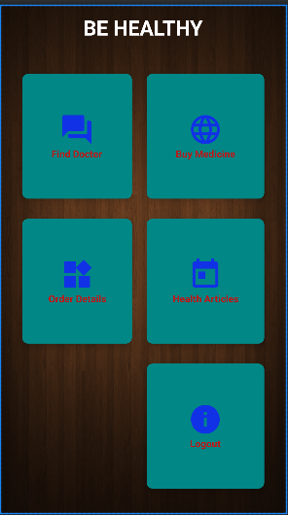

**Figure 5.1 Home page**

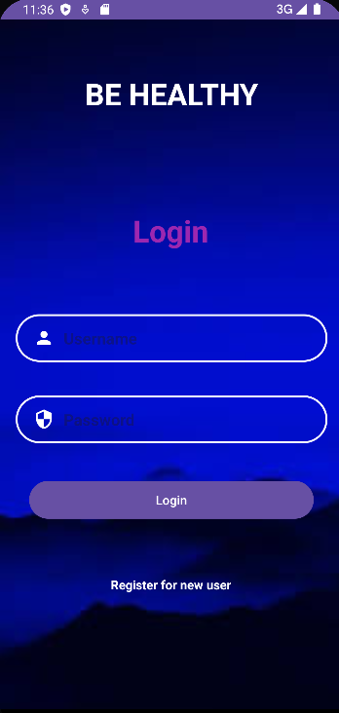

**Figure 5.2 Login page**

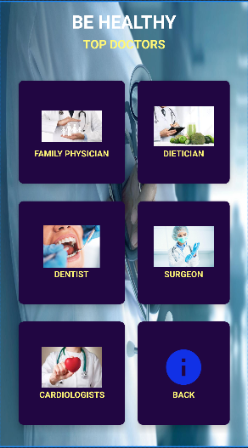

**Figure 5.3 Find Doctor page**

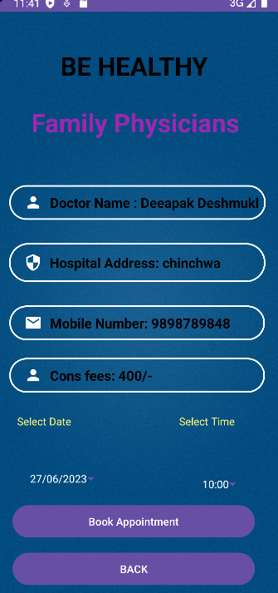

**Figure 5.4 Book Doctor page**

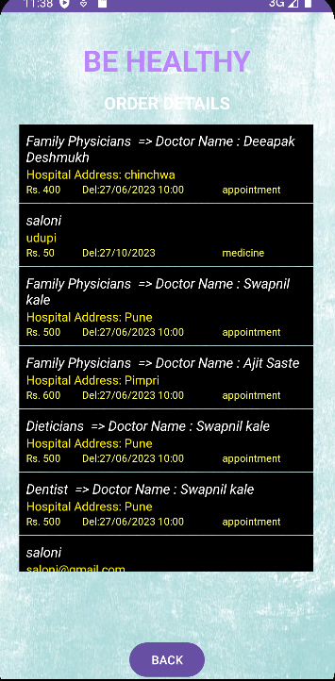

**Figure 5.5 Order details page**

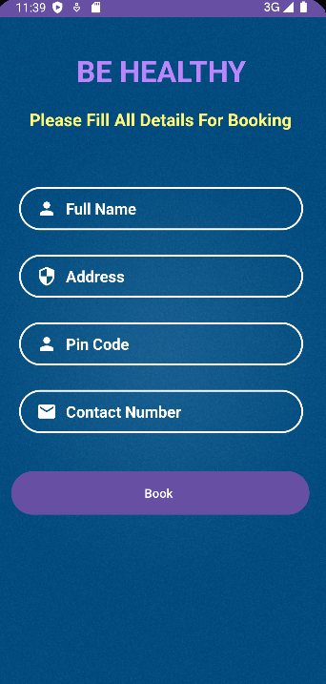

**Figure 5.6 Booking page**

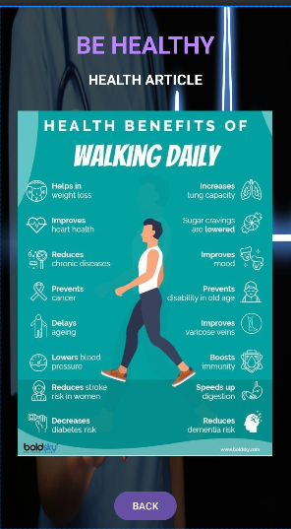

**Figure 5.7 Articles page**

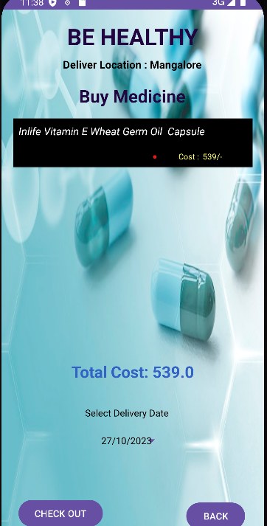

**Figure 5.8 Buy medicine page**

**Chapter 6**

# CONCLUSIONAND FUTURE ENHANCEMENT

## 6.1 Conclusion

Be Healthy is a comprehensive healthcare platform that leverages technology to improve patient access, convenience, and outcomes. By providing features such as an online pharmacy, doctor search, and health tips, Be Healthy aims to streamline the healthcare experience. With a user-friendly interface and secure login/register modules, the platform empowers individuals to actively manage their health and well-being. Be Healthy serves as a centralized solution, offering a range of healthcare services to enhance convenience and support better healthcare decision-making for users.

## 6.2 Future Enhancement

Some potential future enhancements for Be Healthy could include integrating telemedicine services for virtual consultations with healthcare professionals, incorporating wearable device integration for health tracking, implementing personalized health recommendations based on user data, and expanding the platform to include additional healthcare services such as mental health support or chronic disease management tools.

**REFERENCES**

1. <https://developer.android.com/>
2. <https://www.instructtables.com/How-To-Create-An-Android-App-With-Android-Studio/>
3. Google Developer Training, “Android Developer Fundamentals Course-Concept Reference”